Name: Boikanyo Motshwane
Student Number: ST10519905
MR Rulani Kobeni

Part 1 Improvements (Part 2)
Before (Currently)
Using the In line CSS for the Layout of the webpage in building and adding the information needed
- Home Page
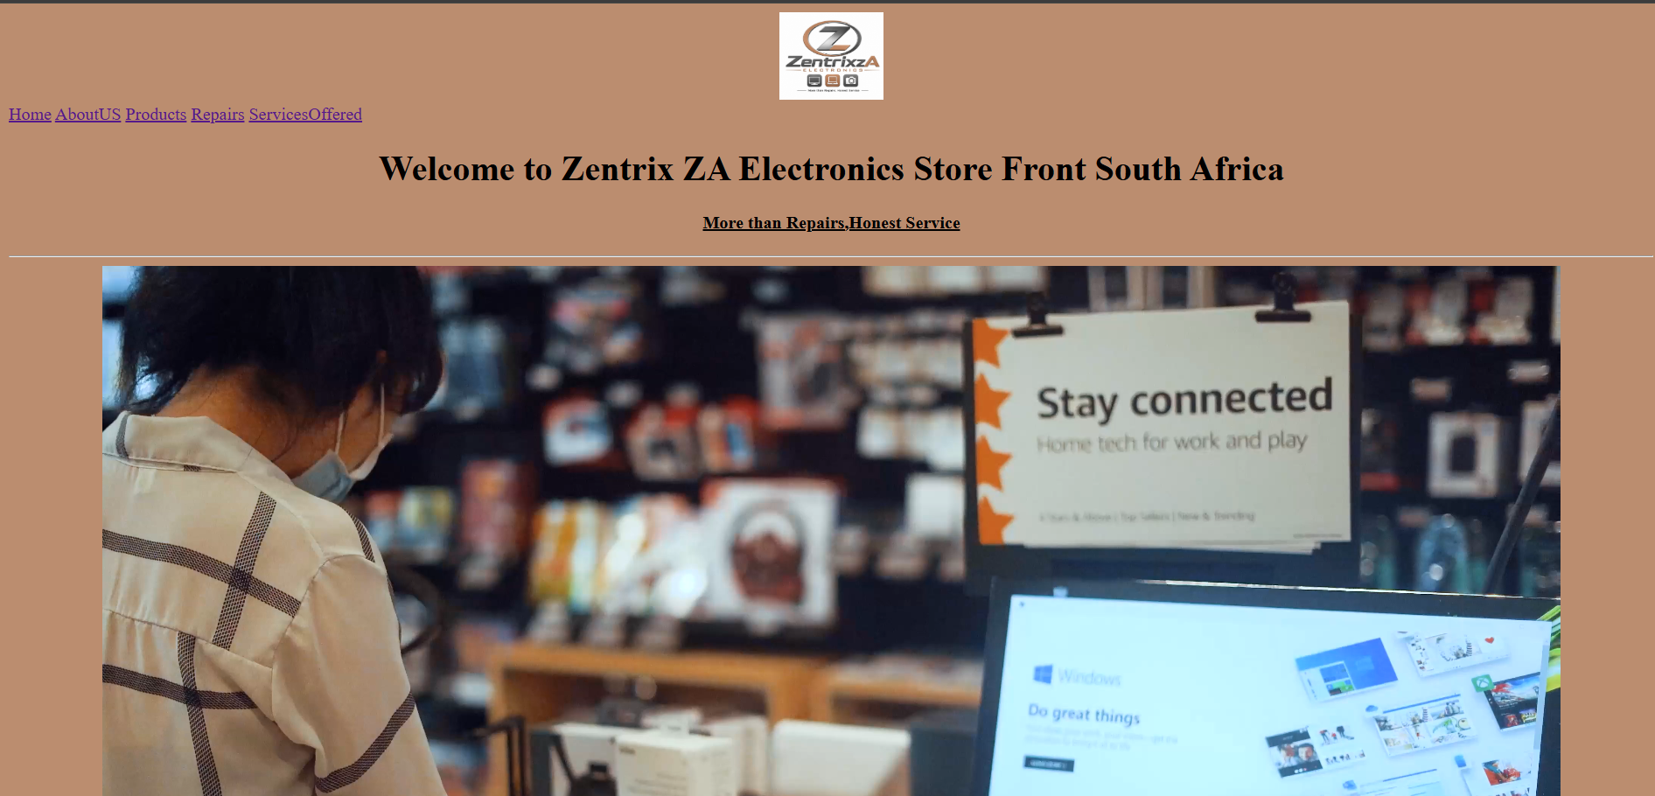

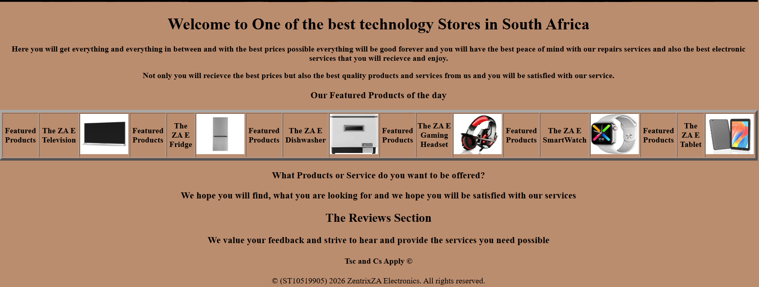
- About US

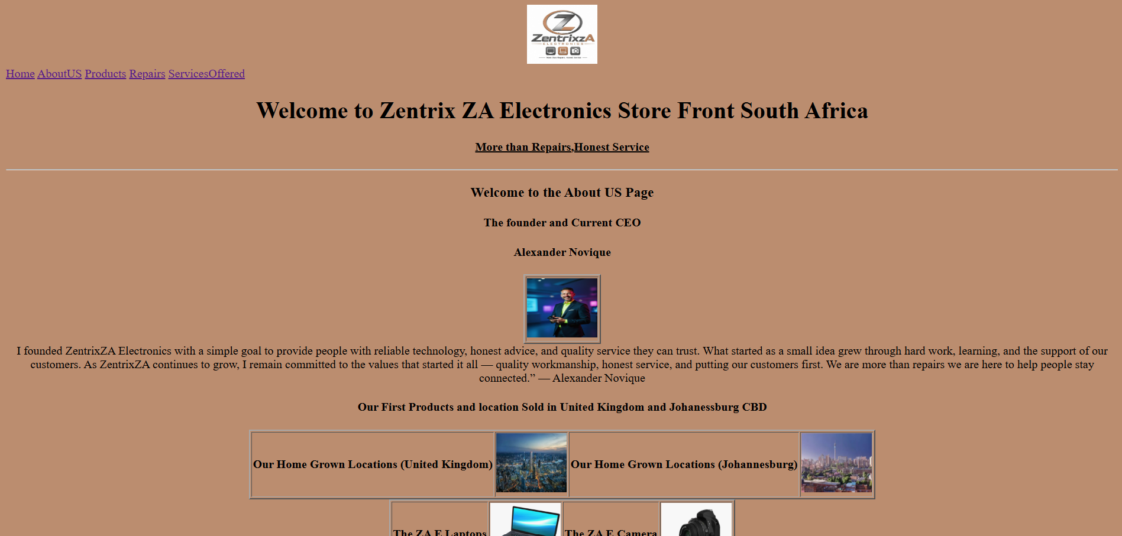

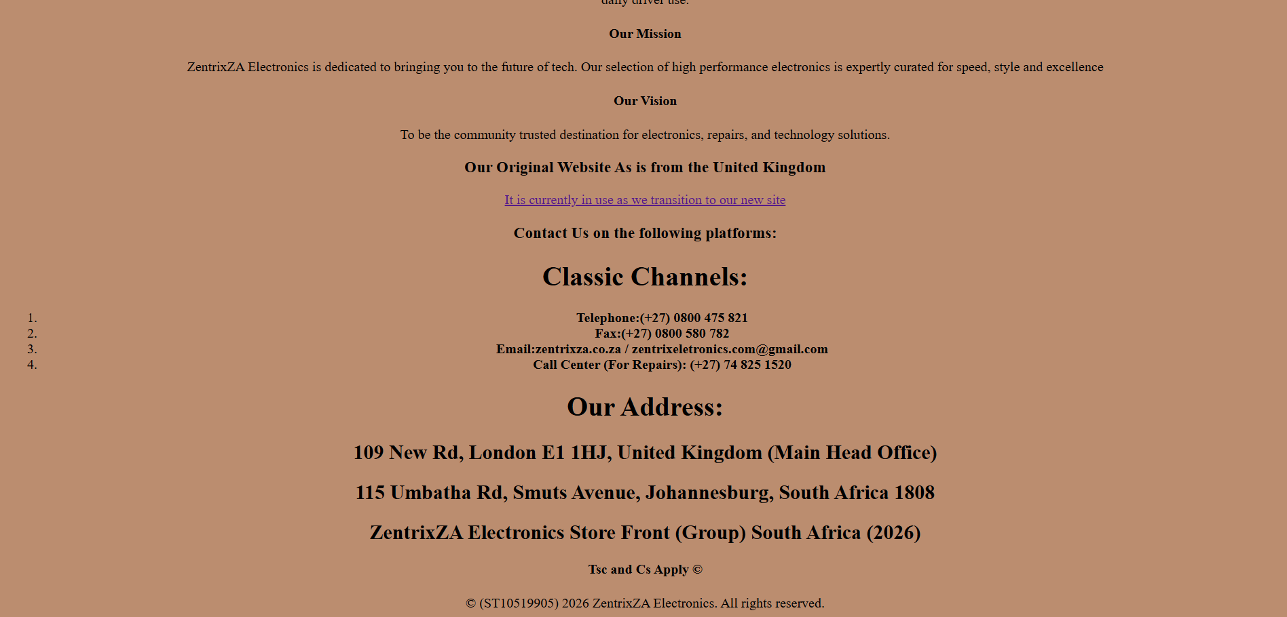

- Products
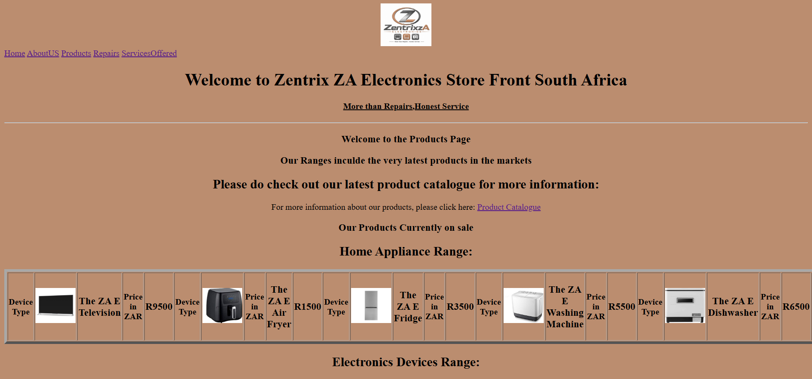

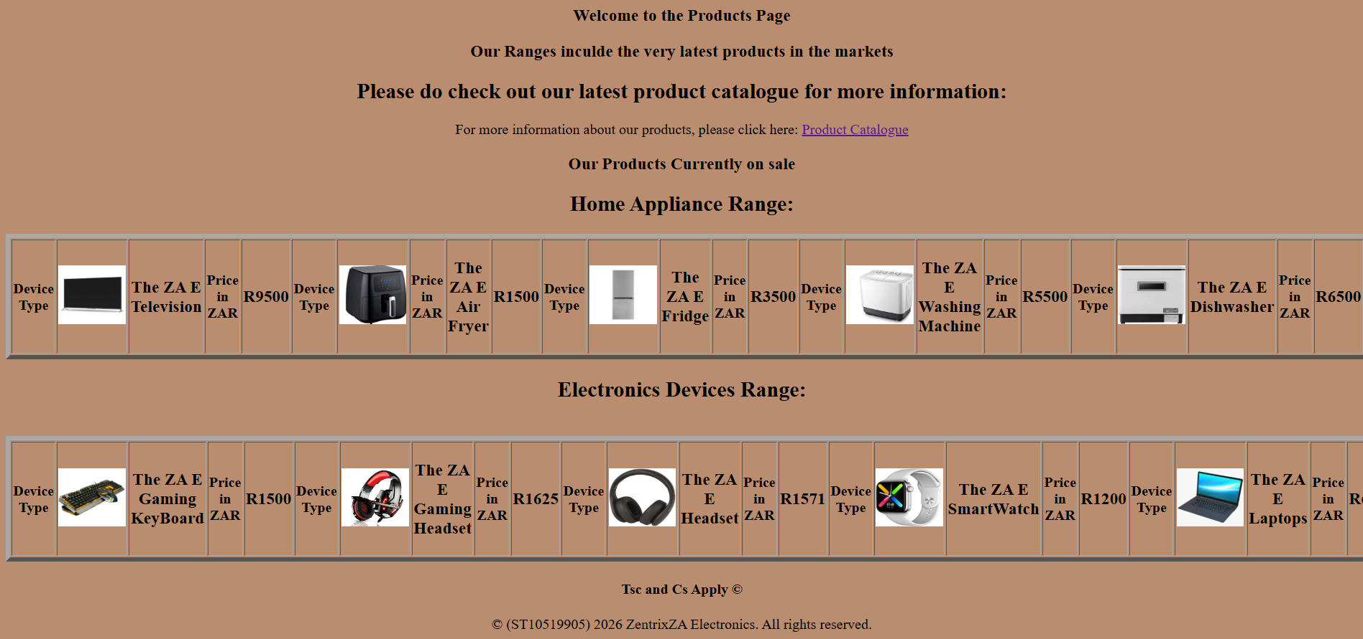
- Repairs
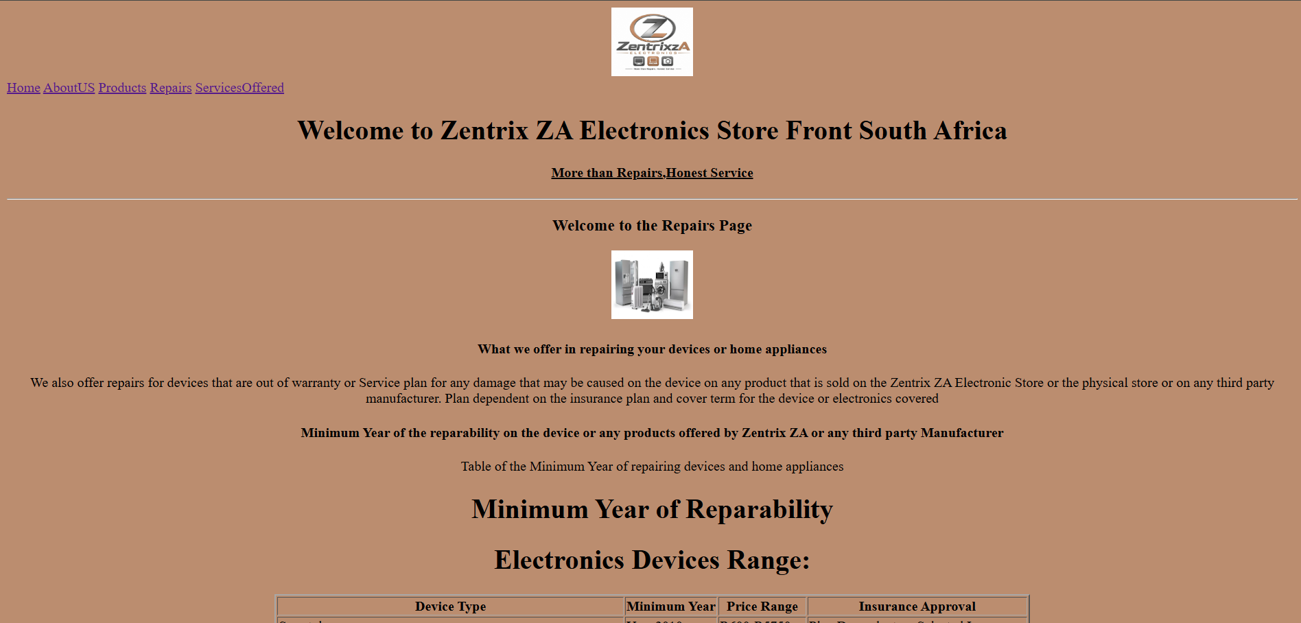
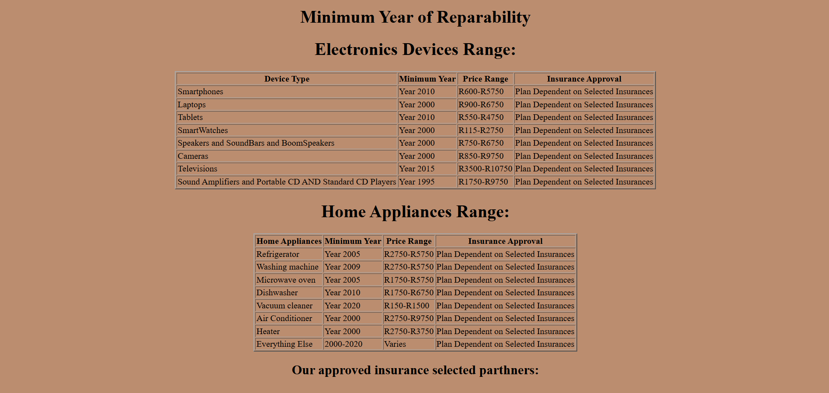
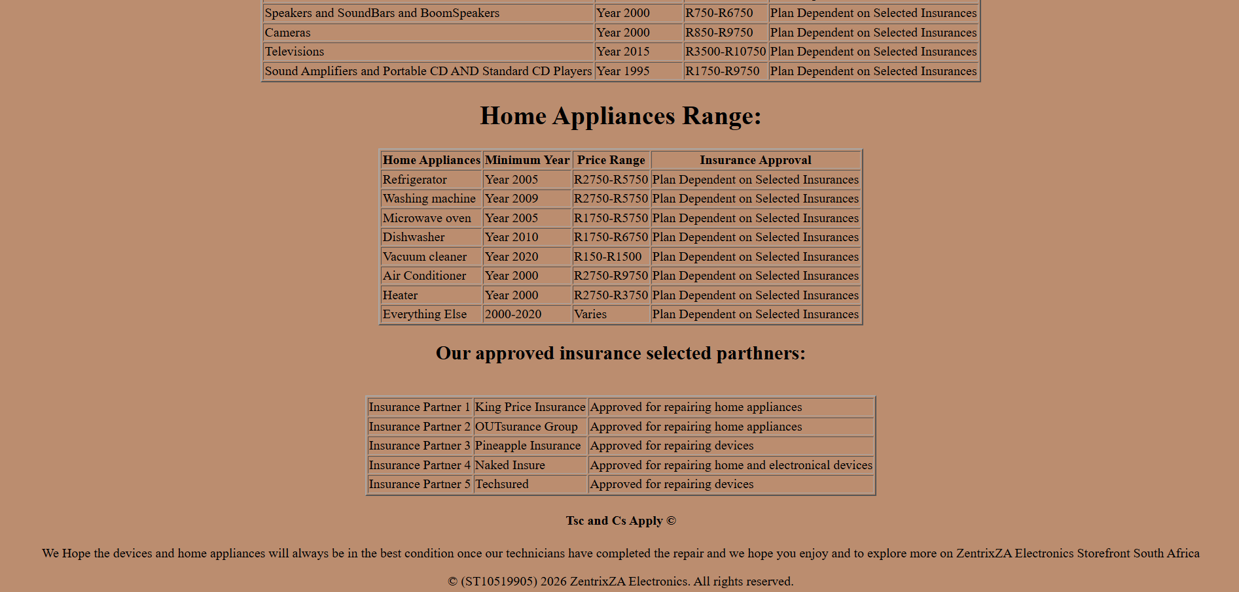

- Services Offered
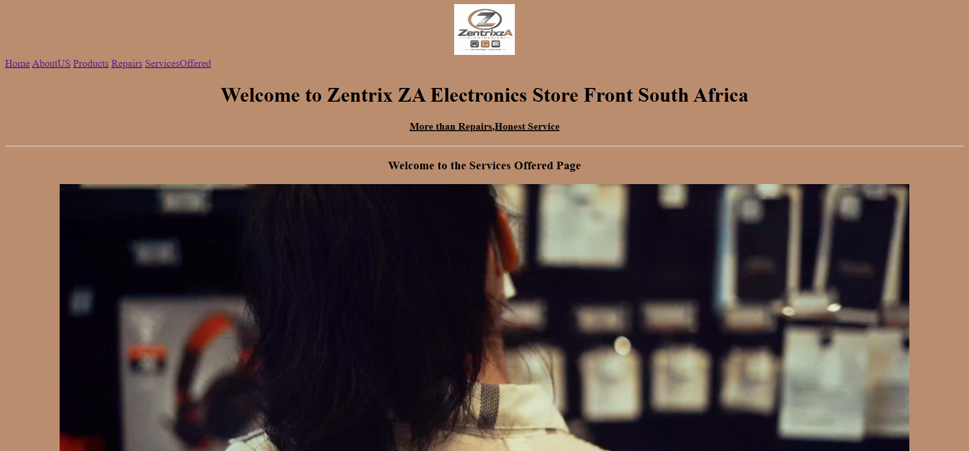

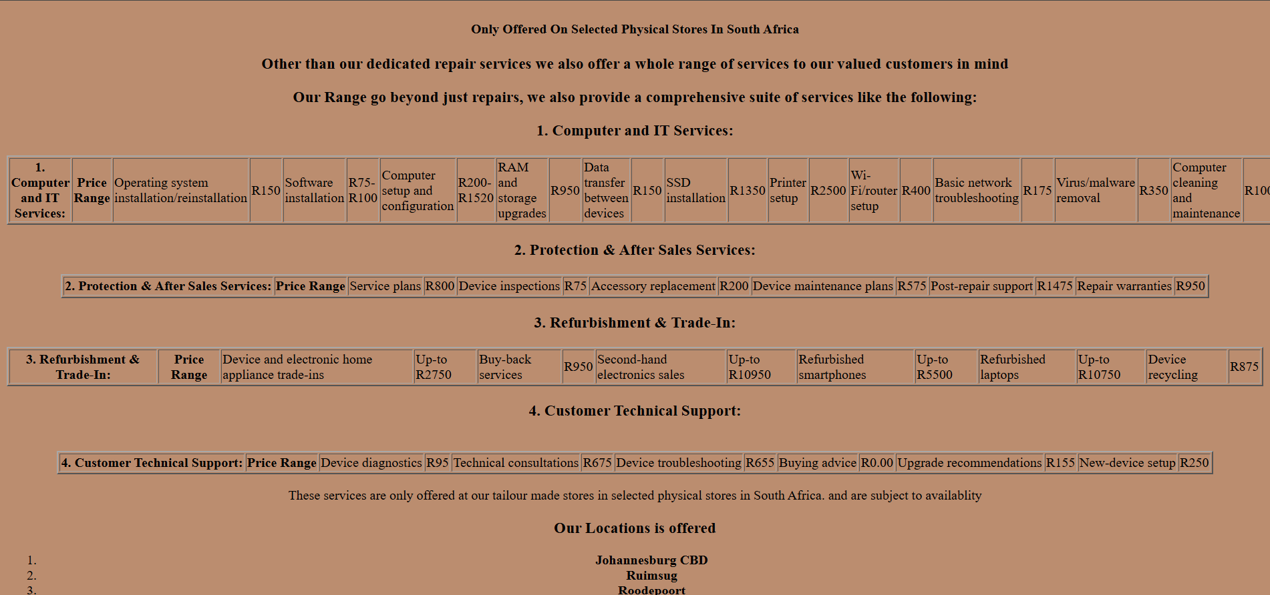

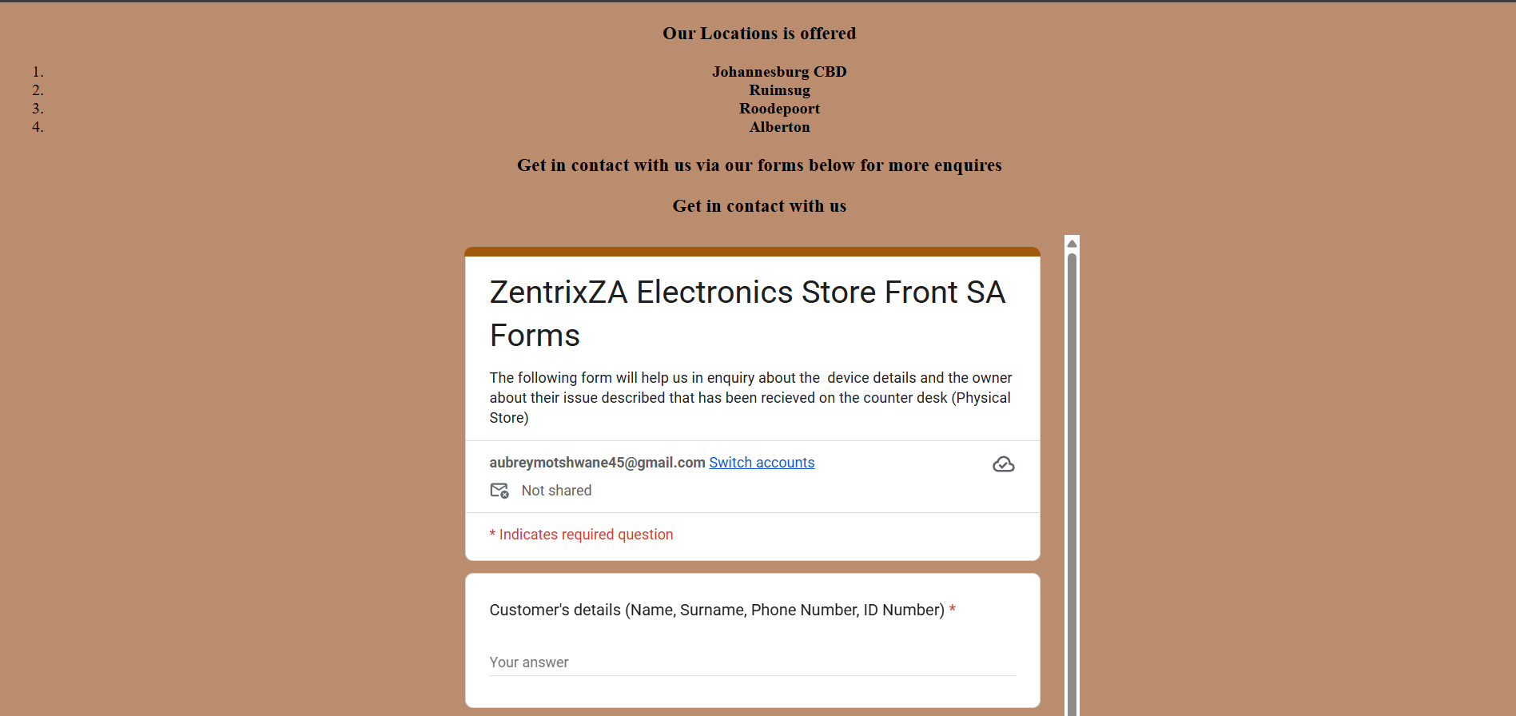
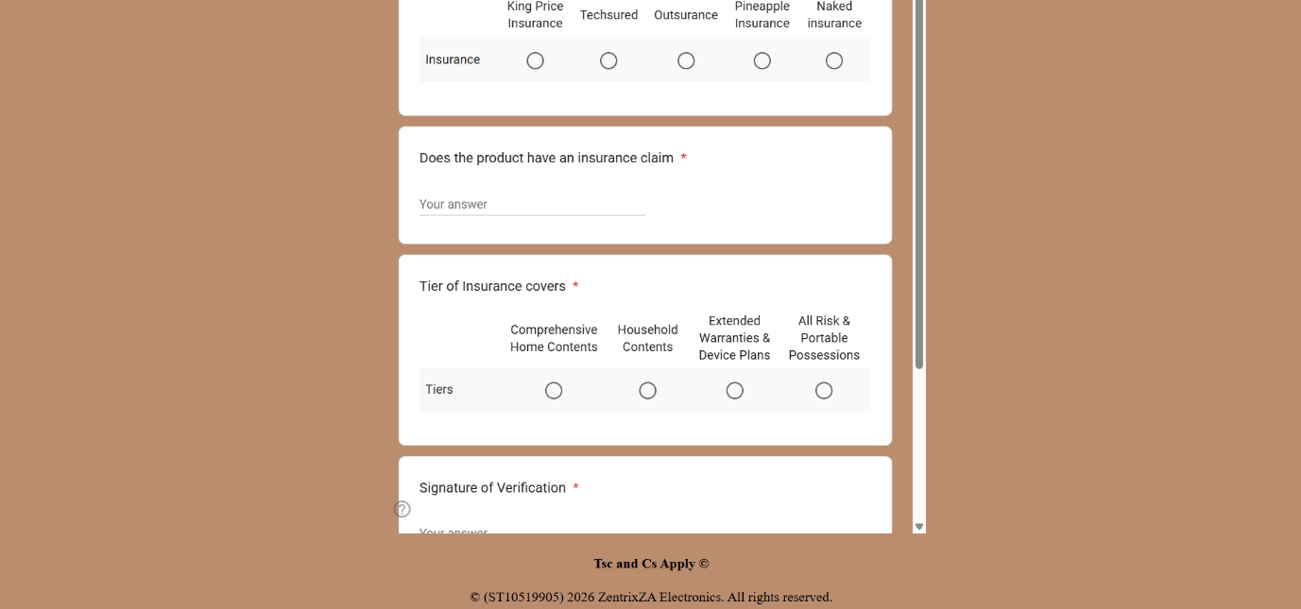

Planned Improvements for the Website (Prototype)
After - Will be using the External CSS for designing and layout format for the Website
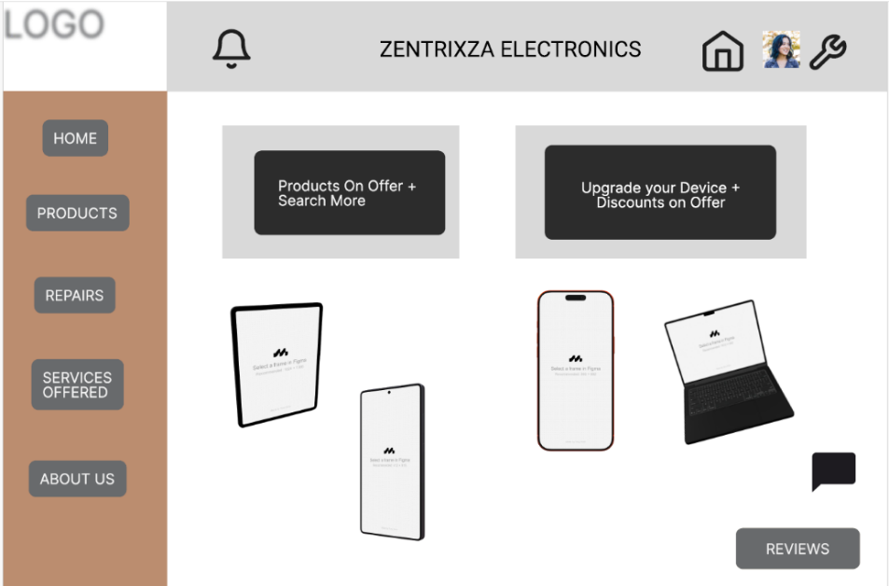
Actual Design (Final For Release)
Home
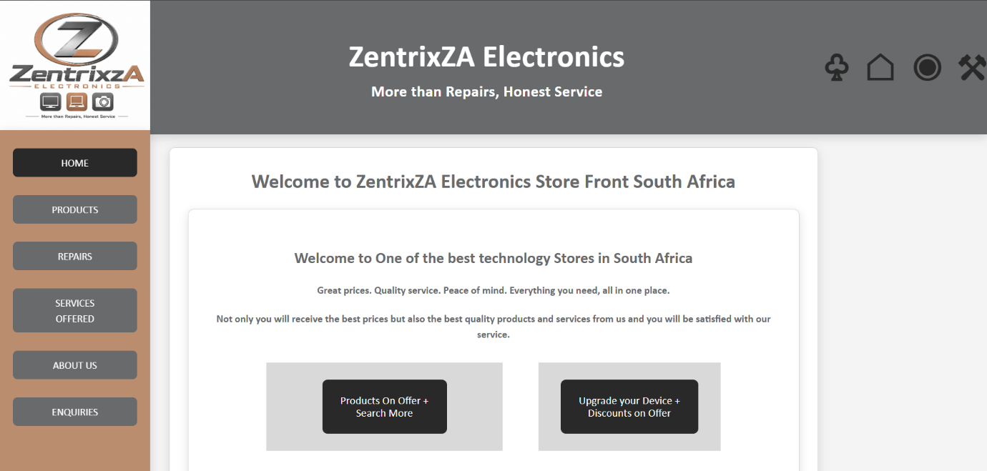

Products
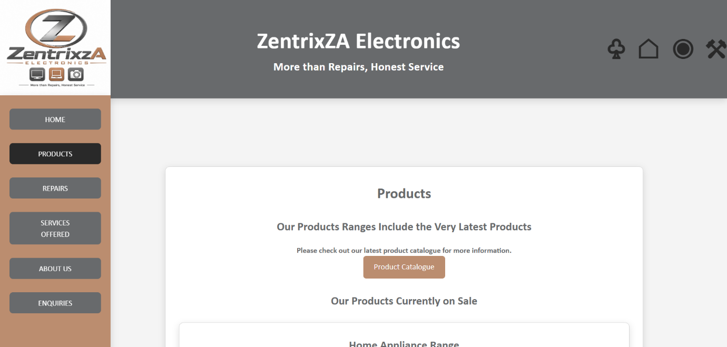

Repairs
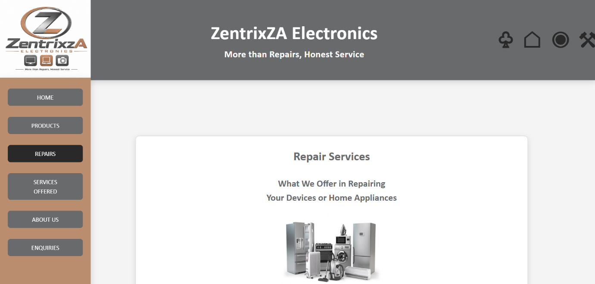

Services Offered

About Us
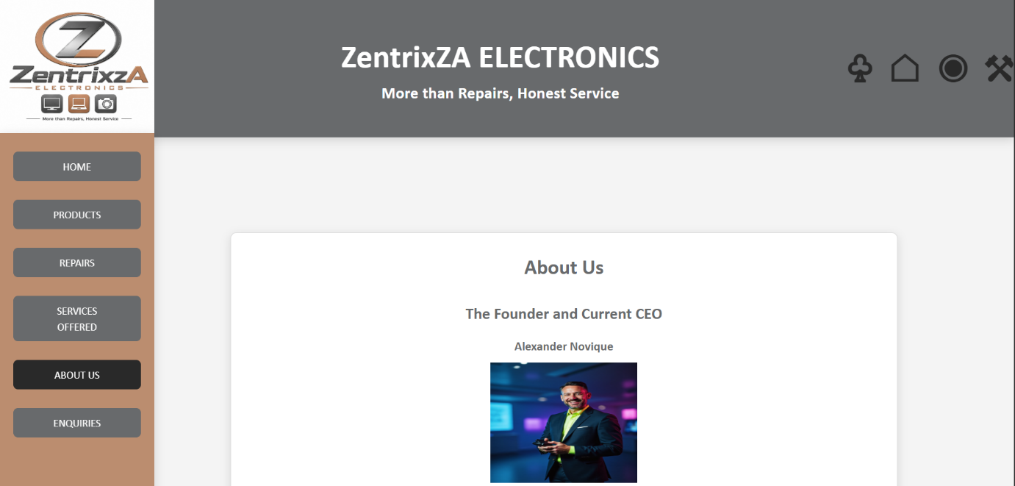

New Page (Enquiries)
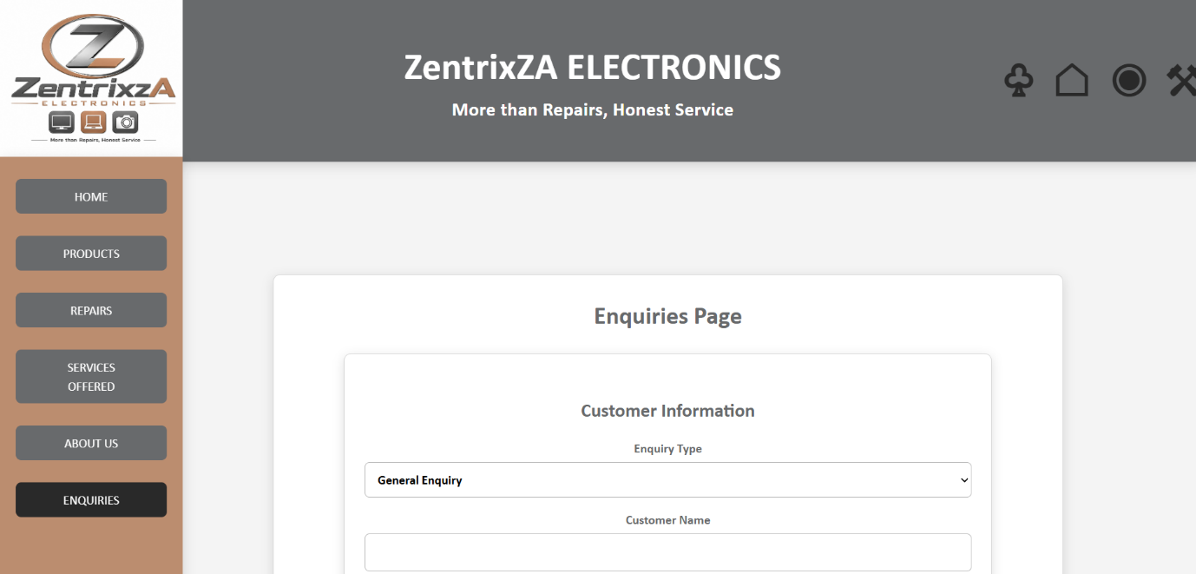
Updated Information (Changelog):
Testing of the website on browser
Firefox – Does work
Google Chrome – Does work
Microsoft Edge – Does Work
- On different devices
Smartphone Layout – Does not work properly
Tablet Layout – Does work
Laptop Layout – Does work
Design and the User Experience:
- The Overall design of the website must have a professional modern look that will give an attention grabbing to the end consumer as a whole as the brand will have to be bold and open to the public about the service they provide in the electronics industry.
- Colour: Brown: Hex code #BB8D6F and Grey: Hex Code #686A6C
- Typography: Calibri, Roboto or Open Sans
- Layout/Design: Open and Flat Design (Minimal Style that has a professional colours, clean typography while using the 2D Shapes with flowing animations that will encompass shadows and gradients with simple UI elements like flat buttons and geometric shapes.
User Experience Considerations: Side bar Navigation in accordance to the Flat Design and to adapt to the colour scheme.

Technical Requirements:
The technical requirements needed for the hosting the website it should be:
Short and easy to remember.
Connected to the chosen web hosting service.
Registered with an accredited domain registrar.
Chosen Name - zentrixza.co.za
- Programming Language Used (Front-End)
CSS3
JavaScript
HTML5
- Frame Works
Bootstrap five
- Hosting
Utilising a shared type based web-hosting site with a .co.za do domain, SSL Certificate, including daily backups also include the Uptime to ensure the website remains accessible and include the SSD storage for a faster load-times when accessing the website.

References
For CSS and HTML (UPDATED)
Mozilla Developer Network (MDN) (2026a) <link> HTML external resource link element. Available at: https://developer.mozilla.org/en-US/docs/Web/HTML/Reference/Elements/link (Accessed: 18 September 2026).
Mozilla Developer Network (MDN) (2026b) Getting started with CSS. Available at: https://developer.mozilla.org/en-US/docs/Learn_web_development/Core/Styling_basics/Getting_started (Accessed: 18 September 2026).
Mozilla Developer Network (MDN) (2026c) Class selectors. Available at: https://developer.mozilla.org/en-US/docs/Web/CSS/Reference/Selectors/Class_selectors (Accessed: 18 September 2026).
Mozilla Developer Network (MDN) (2026d) CSS box model. Available at: https://developer.mozilla.org/en-US/docs/Web/CSS/Guides/Box_model (Accessed: 18 September 2026).
Mozilla Developer Network (MDN) (2026e) CSS flexible box layout. Available at: https://developer.mozilla.org/en-US/docs/Web/CSS/Guides/Flexible_box_layout (Accessed: 18 September 2026).
Mozilla Developer Network (MDN) (2026f) HTML elements reference. Available at: https://developer.mozilla.org/en-US/docs/Web/HTML/Reference/Elements (Accessed: 18 September 2026).
World Wide Web Consortium (W3C) (2026a) Web standards. Available at: https://www.w3.org/standards/ (Accessed: 18 September 2026).

For HTML (Previously)
Zentrix Electronics, 2021, Electronics Website (Targeted Organization) [Online] Available at: <https://www.zentrixeletronics.com/> [Accessed on 29 July 2026]
@zentrixelectronics (wix), 2026, Electronics store. [Facebook], March 2026, Available at: <https://web.facebook.com/wix?_rdc=1&_rdr#> [Accessed on 01 August 2026]
Digital Platforms, 2008, Electronics Website Available, 6 Phases of the website design and development process at :< https://www.digitalplatforms.co.za/6-phases-of-the-web-site-design-and-development-process/> [Accessed on 2 August 2026]

Web Development Technologies - A Practical Guide, 2024, my annual guide to every web development technology that you can think of. We cover everything including frontend, backend, full stack, DevOps and more.,[Video Online] Available at <https://www.youtube.com/watch?v=8sXRyHI3bLw> [Accessed on 3 August 2026].

Back to bugherd.com, 2023, The Art of Website Project Management: A Comprehensive Guide [Online], Available at: <https://bugherd.com/blog/website-project-management> [Accessed on 2 August 2026]

W3Schools, 2026, HTML Responsive Web Design,[online], Available at:<https://www.w3schools.com/html/html_responsive.asp> [Accessed on 5 August 2026]

